**Project plan**

***HeardIT***

|  |
| --- |
| **Date : 26/05/2024** |
| **Version : 0.5** |
| **Status : Complete** |
| **Author : Mihail Vasilev** |

#### Version

|  |  |  |  |  |
| --- | --- | --- | --- | --- |
| **Version** | **Date** | **Author(s)** | **Amendments** | **Status** |
| 0.1 | 04/03/2024 | Mihail Vasilev | Initial project plan version | Complete |
| 0.2 | 15/03/2024 | Mihail Vasilev | Updated – 1.5, 1.6, 2.2, 2.3, 3.1 | Complete |
| 0.3 | 24/03/2024 | Mihail Vasilev | Updated – 1.5, 1.6, 2.2, 2.3, 3.3, 3.4, 5 | Complete |
| 0.4 | 14/04/2024 | Mihail Vasilev | Updated – 1.6, 2.3, 2.5, 3.4 | Complete |
| 0.5 | 26/05/2024 | Mihail Vasilev | Updated – 1.4, 2.5, 3.4 | Complete |
|  |  |  |  |  |

**Communication**

|  |  |  |
| --- | --- | --- |
| **Version** | **Date** | **To** |
| 0.1 | 04/03/2024 | Mihail Vasilev |
| 0.2 | 15/03/2024 | Mihail Vasilev |
| 0.3 | 18/03/2024 | Mihail Vasilev |
| 0.4 | 14/04/2024 | Mihail Vasilev |
| 0.5 | 26/05/2024 | Mihail Vasilev |
|  |  |  |

Table of Contents

1. Project Assignment 4

1.1 Context 4

1.2 Goal of the project 4

1.3 Scope 5

1.4 Conditions and technologies 5

1.5 Finished products 6

1.6 Research questions 7

2. Approach and Planning 8

2.1 Approach 8

2.1.1 Test approach 8

2.2 Research methods 8

2.3 Learning outcomes 9

2.4 Breakdown of the project 11

2.5 Time plan 11

3. Project Organization 12

3.1 Team members 12

3.2 Communication 12

3.3 Configuration and Test environment 13

3.4 Architecture design 13

4. Finance and Risks 15

4.1 Cost budget 15

4.2 Risks and fallback activities 15

5. Other remarks 16

# Project Assignment

## Context

HeardIT is a music sharing platform where you will be able to discover, listen and learn how to play to your favorite songs from a plethora of indie bands. The website focuses on small to medium music creators and people interested in learning how to play the songs on their instruments. The application provides several features that allow users to have an interactive experience combining the listening and learning aspect in one easy-to-find place.

Songwriters will have the ability to upload their tracks, the chords/tabs, lyrics and any other information that will allow their fans to be able to not only listen to the songs but also learn to play them.

Fans will be able to experience these features easily through the interactive user interface and will be able to leave comments, likes and make playlists with their favorite songs.

This way HeardIT will be a place where music creators and fans will have the opportunity to interact, share their experience, learn and get closer to the art of music together.

## Goal of the project

The goal of the HeardIT music sharing application is to provide its users with a place where they can share, enjoy and learn their favorite music. The application will occupy the niche of being a music sharing platform where users can not only find the tracks from their favorite artists but also the chords and lyrics that they can learn so that they can play/sing along with the songs.

In technical terms, the main goal of the project is to create a scalable, reliable and user-friendly web-application that follows the established enterprise standards for developing mainstream software services. The project will focus on delivering a working solution capable of passing the modern requirements for software solutions. The application will follow the modern principals of software developing, utilizing the most suitable technologies, software architecture principles, the best practices and methods of testing. HeardIT will be a modern application that lives up to the high standards of the modern IT world.

## Scope

|  |  |
| --- | --- |
| **The project includes:** | **The project does not include:** |
| 1. Back-end services and database structure | 1. External hardware |
| 1. Front-end web application | 1. Paid software |
| 1. Documentation |  |

## Conditions and technologies

In this paragraph I will state the technologies and working methodologies that I am going to be using and following during the creation of this project. These technologies have been chosen due to my expertise, proficiency and previous experience with them. The working strategy that I am going to use is also chosen based on the assignment’s requirements and my previous experience.

These technologies include:

* Back-end and services
  + Java SpringBoot
* Front-end
  + ReactJs
* Git
* Database
  + MySQL
  + Google Cloud Storage
* Deployment
  + Docker
  + Kubernetes

Work strategies include:

* Agile
* Scrum

## Finished products

The finished products are divided into two main parts:

* HeardIT Documentation – contains all documentation created during and for the HeardIT application
* HeardIT Application – contains the different parts that together form the actual application

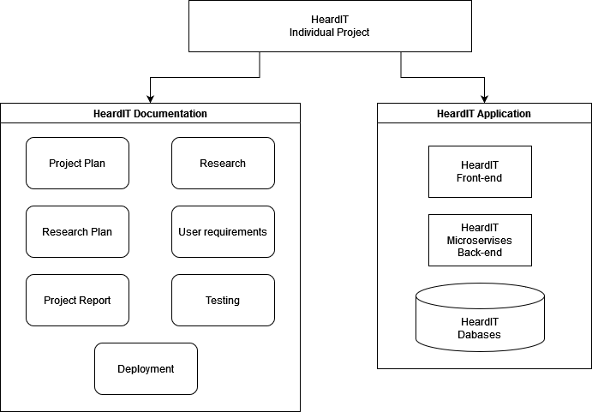

Figure 1 - Finished Products

## Research questions

**Project research question:**

* How can the HeardIT application be developed in alignment with the modern standards for software applications?

**Main questions:**

* What is the most suitable architecture type for the HeardIT web-application?
  + What type of architecture designs are suitable for the HeardIT application?
  + Which architecture design meets the scalability and stability requirements?
  + Which architecture design meets the maintainability requirements?
  + Which architecture design meets the requirements for cloud native applications?
  + Which architecture design meets the security requirements?
* What is the most suitable approach for distributing and storing the data used by HeardIT?
  + What type of data is HeardIT working with?
  + What is the most suitable approach for storing and handling the data for the songs?
  + What is the most suitable approach for storing and handling user data?
  + What is the most suitable approach for storing and handling other kinds of needed data?
  + What is the most suitable approach to distribute and synchronize the data in the databases?
  + What is a suitable approach and technology for establishing communication between different services in the application?
* What technologies and methods are most suitable for deploying HeardIT to the cloud?
  + What cloud providers are suitable for the HeardIT application?
  + How to automate the deployment process to the cloud?
  + How to set-up the CICD pipeline for the front and back-end repositories?
  + How to deploy back-end cluster to Google Kubernetes Engine (GKE)?
  + How to perform load testing of the application?
* How can I ensure that HeardIT provides its users with sufficient data security mechanisms and follows the modern standards and regulations for data protection?
  + What are the main general application security risks that HeardIT needs to be protected against?
  + What measures need to be taken to comply with the GDPR?
  + How to ensure that the application remains secure and well-maintained?

# Approach and Planning

## Approach

The approach that I am going to use during the development of the HeardIT application will follow the Agile working methodology. During my previous studies, internship and work experience I have acquired a significant amount of experience working Agile I believe that this will suit my project the best.

The tasks will be described in one or more large epics with specific research and user stories with their own acceptance criteria. These user stories will be then planned accordingly over the sprints. At the end of each sprint, the results of each sprint will be presented to the teachers and coaches. At the end of the assignment the results will be presented in more detail to the semester teachers and coaches. All work will be documented and reviewed according to the modern software development standards. The application will be version controlled in several Git repositories.

### Test approach

Testing will be performed to ensure the quality of the project and its components. To this end the testing strategy that will be performed will include: manual testing, unit testing, component testing, service testing, load and stress testing. These are the main outlines of the testing strategies that I am going to implore during the development of HeardIT.

## Research methods

The All parts of the DOT research methodology framework will be applied during the development of the project. These methods will be used, since it will require research in a wide range of different fields in order to find a suitable solution to the problem the main research question poses.

Since there are many aspects and topics that I will have to explore, I have decided to split them into several main questions. Each of these questions will be researched in greater detail in their own separate documents.

For the main questions these research methods will be applied:

* What is the most suitable architecture type for the HeardIT web-application? - Literature study, Expert interview, Design pattern research, Document analysis, Brainstorm, Problem analysis
* What is the most suitable approach for distributing and storing the data used by HeardIT? - Literature study, Expert interview, Document analysis, Problem analysis, Pitch
* What technologies are most suitable for deploying HeardIT to the cloud? - Literature study, Expert interview, Available product analysis, Prototyping, Problem analysis, System test
* How can I ensure that HeardIT provides its users with sufficient data security mechanisms and follows the modern standards and regulations for data protection? - Literature study, Problem analysis, System test, Component Test, Expert Interview, Non-functional test, Security test

## Learning outcomes

**Learning outcome 1:**  
[Professional Standard] You take responsibility when solving ICT issues. You define and carry out your applied research using relevant selected methodologies and provide advice to your stakeholders in complex and uncertain contexts. You substantiate and validate future-oriented choices by use of law, ethical, intercultural, and sustainable arguments.

This learning outcome focuses on the professionalism that I must display during this semester. It applies to all parts of the development process, participating in meetings with the teachers, product owners and my team members. Delivering professional products within the established deadlines and constraints is also a major part of proving this learning outcome. Applied research will be a vital part of the development process. This research will allow me to make better decisions during all phases of the project while also taking into consideration the scope, relevancy and any other substantial context that might arise. The proof for this learning outcome will be all the of the professional products that I deliver and all the related documentation, process reports and research that was conducted during this semester.

**Learning outcome 2:**  
[Personal Leadership] You independently formulate goals and actions that demonstrate leadership in your own long-term development as an ICT professional. You show that you have a professional attitude and can carry out these actions and achieve your goals, adjusting them as necessary.

Personal leadership is a major part of this semester’s structure since we have a lot of freedom to choose not only our project and technologies but also the process that we are going to undertake. The planning, research, design and FeedPulse documents will be the main proof for this learning outcome. Each part of the assignment will be carefully planned, researched and developed by me and I will be the main person responsible for delivering the final products. Another very important part of showing my personal leadership will be my feedback sessions with my teachers. Regular meetings with them will be scheduled and attended. This will be mainly shown in the FeedPulse reports that are created after each meeting with each teacher as well as applying the feedback and improving upon it with every new sprint.

**Learning outcome 3:**[Scalable Architectures] Besides functionality, you develop architecture of an enterprise software based on explicitly stated software quality requirements. You explicitly focus on quality requirements most relevant to your projects’ contexts. Quality requirements dictated by law (e.g. GDPR) and ethics (e.g. security) must always be addressed. You design your system with future adaptation in mind. You assess the extent in which the quality requirements are met by your software implementation.

Creating applications with professional architecture that meets the criteria for the enterprise software requirements is a major part of this semester. Both the individual and group projects will be applications that follows the modern strategies to create a future-proof enterprise level application. As such, extensive research, development and quality control will be conducted during the creation of the applications. The main proof for this learning outcome will be the URS and design documents, architecture research and design documents, product reports and testing reports that will be created during the development of the applications the meet the modern quality standards.

**Learning outcome 4:**  
[Development and Operations (DevOps)] You set up environments, tools and processes which support your continuous software development process. Your deployment environment supports this by being able to deploy an integrated software system and monitor the running parts of your application for quality attributes.

Continuous software development is situated at the core of modern software development theory and is a vital part of my semester’s projects. The CI/CD environment that will take care of the automated testing, quality control, deployment and delivery of the applications. Extensive and detailed research and development will be conducted in order to establish a proper CICD environment. This will be beneficial to my development process since establishing it will allow me to be more productive and effectively deliver. As such appropriate documentation that focuses on the DevOps part of the assignment will be created that goes into detail of how each part of the Continuous Integration and Deployment/Delivery is employed. These documents as well as the real set-up of the DevOps environment will be the proof for this learning outcome.

**Learning outcome 5:**  
[Cloud Native] You develop your software according to the best practices of cloud native development. You deploy (parts of) your application to a cloud platform. You integrate cloud services (for example: Serverless computing, cloud storage, container management) into your software, and can explain the added value of these cloud services for your software quality.

Creating cloud native software solutions is at the core of modern software development standards. Acquiring knowledge and experience and executing upon it will play an important part of the development process of the applications that I will be working on this semester. Due to the nature of the applications, they will have to be deployed to external cloud platforms. The deployment research and process will be documented and regularly presented to the teachers and stakeholders. The applications working in a real cloud environment using real cloud services as well as the according documentation and infrastructure to support them will be the proof for this learning outcome.

**Learning outcome 6:**  
[Security by Design] You investigate how to minimize security risks for your application, and you incorporate best practices in your whole software development process.

Security is a vital part of any modern application that contains data for its users and products. In order for the applications to allow its users to have a pleasant and secure experience while using it, extensive research and development will be conducted. This research will allow me to determine the best practices and methods that I can apply to keep the users privacy and security. Preventing breaches, data leaks and other types of insecurities and possible attack surfaces is from vital importance in the modern software development sphere and as such will play a big part in the development process. As proof for this outcome will be the research documents related with the security aspects, documents detailing how these methods are implemented and what potential threats were detected and prevented.

**Learning outcome 7:**  
[Distributed Data] You apply best practices for handling and storing large amount of various data types in your software. You use the non-functional requirements of your enterprise software, especially legal and ethical considerations to guide your design choices in protecting and distributing data in your software without compromising other software qualities.

The projects that I am a part of this semester allow its users to have access to a vast amount of data and facilitate a great amount of information. As such, it is expected that both my individual and my group projects will be able to handle and store this data securely but also being easy and fast to access for its users. The best practices in modern development will be researched, applied and the whole process will be documented. Research documents that delve into the different actions needed to facilitate this kind of vast data, documents that detail how the best practices are applied and real implementations will be the proof for this learning outcome.

## Breakdown of the project

The project will be split into 5 sprints each following the Agile methodology. At the beginning of each sprint the tasks will be split and planned accordingly. At the end of the sprint a short personal retrospective will be created. Each sprint will follow this approach.

## Time plan

|  |  |  |  |
| --- | --- | --- | --- |
| **Phasing** | **Delivered** | **Start** | **End** |
| Sprint 1 | Project Pitch, Project Plan, Research Plan, User requirements, HeardIT application v1 | 04/03/2024 | 24/03/2024 |
| Sprint 2 | HeardIT application v2, Research-Architecture-HeardIT, Research-CloudDeployment-HeardIT, Application deployed to GCP | 25/03/2024 | 14/04/2024 |
| Sprint 3 | HeardIT application v3 (Big redesign and update to the whole application), Updates to Research-CloudDeployment-HeardIT, Application deployed to Google Kubernetes engine and Fontys NetLab | 15/04/2024 | 12/05/2024 |
| Sprint 4 | HeardIT application v4, Load testing established and implemented in CICD pipeline, Research-DataDistribution-HeardIT, OWASP Top 10 security report | 13/05/2024 | 02/06/2024 |
| Sprint 5 | HeardIT application v5 | 03/06/2024 | 23/06/2024 |

# Project Organization

## Team members

|  |  |  |  |
| --- | --- | --- | --- |
| **Name + Phone + e-mail** | **Abbr.** | **Role/tasks** | **Availability** |
| Mihail Vasilev, +359884921350,  m.vasilev@student.fontys.nl | *Student* | *Implementer, Main contact person* | *Available 5 days a week* |
| Erik van der Schriek  [e.vanderschriek@fontys.nl](mailto:e.vanderschriek@fontys.nl) | *Technical teacher* | *Monday afternoon*  *Thursday afternoon* | *Available 2 days a week* |
| Onno Marsman  [0.marsman@fontys.nl](mailto:0.marsman@fontys.nl) | *Technical teacher* | *Monday afternoon*  *Thursday afternoon* | *Available 2 days a week* |
| Robbert Pas  [r.pas@fontys.nl](mailto:r.pas@fontys.nl) | *Semester Coach* | *Monday morning*  *Wednesday morning* | *Available 2 days a week* |

## Communication

* Technical supervisors:
  + Weekly meetings
  + Reports in FeedPulse
* Semester coach:
  + Bi-Weekly meetings
  + Reports in FeedPulse

## Configuration and Test environment

GitHub actions CI/CD development and test environment will be used in order to test and deliver the HeardIT application. A pipeline that automatically builds, tests, checks for vulnerabilities, ensures the code quality meets the required standards and at a later stage, deploys the application will be created.

The pipeline will be split into several stages, each of them focusing on a different part of the CI/CD process. The build and test stages will determine if the application is being built properly and if the current functionality is still operational. The checking for vulnerabilities and code quality will be created in order to find any potential issues that might have been created. If the pipeline succeeds and there are no detected issues with the code, the application will be automatically be deployed to the cloud.

This process is illustrated in Figure 2.

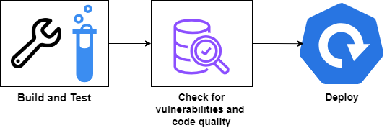

Figure 2 - CI/CD Pipeline

## Architecture design

Establishing the software architecture of the HeardIT web-application is an essential part of the development process. There are several constraints when it comes to deciding and creating the architecture design. These constraints follow from the fact that HeardIT should be able to perform under high traffic, should be scalable and capable of sustaining high user loads while maintaining its responsiveness and availability.

As such the architecture design that I have determined is best suited for HeardIT is the *Microservices* type of software architecture. This decision was made after conducting careful research that allowed me to see the benefits of choosing this type of architecture. For more information about the research, please refer to *Research-Architecture-HeardIT.docx*.

I have also illustrated the architecture design in Figure 3.

Figure 3 - C1 and C2 architecture design

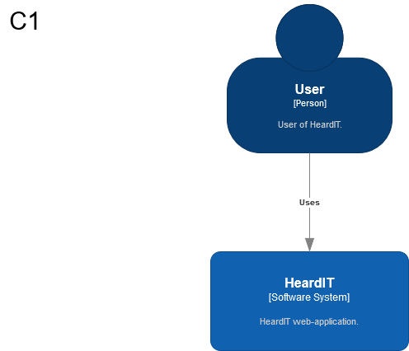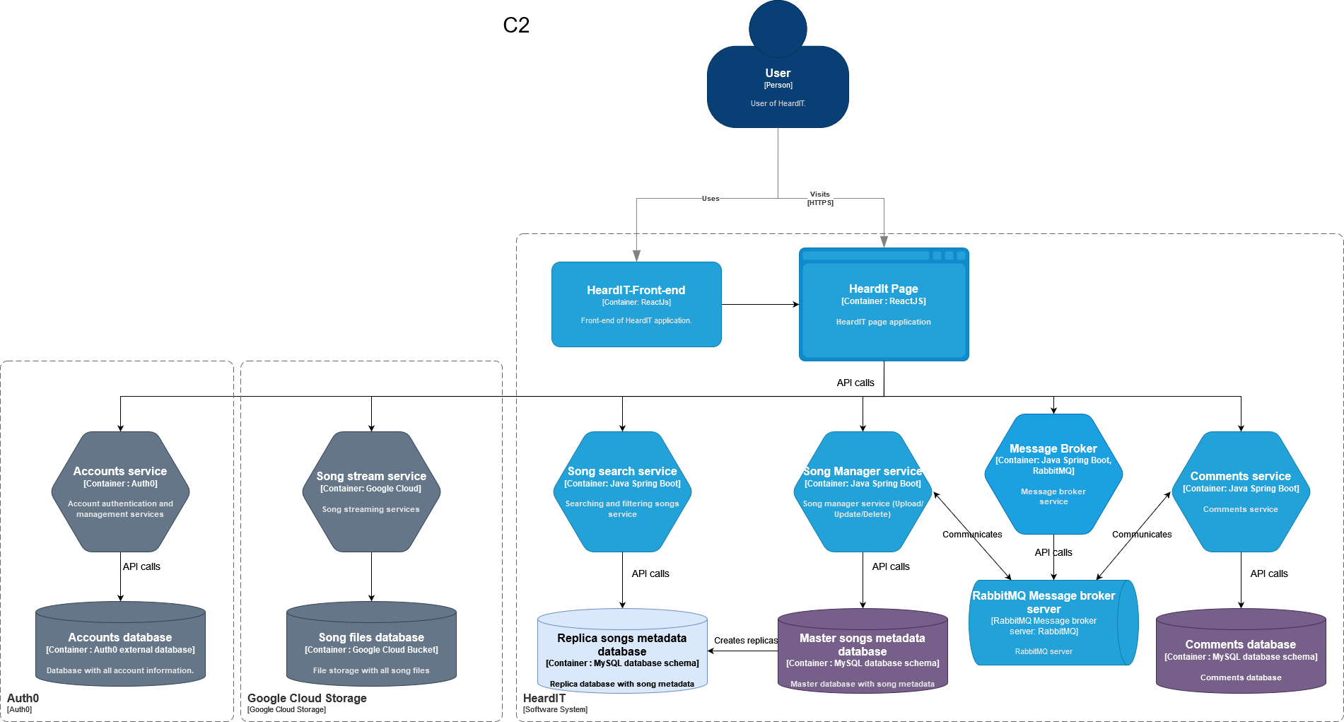

# Finance and Risks

## Cost budget

For this project there are no specific costs expected. New work equipment and software investments into outside sources will not be required in order to complete the project.

## Risks and fallback activities

|  |  |  |
| --- | --- | --- |
| **Risk** | **Prevention activities included in plan** | **Fall-back Activities** |
| 1. Issue is outside of the project’s scope | Refine issue | Scale down issue requirements |
| 1. Inaccurate estimation of the complexity of an issue | Refine issue | Scale down and re-prioritize features |
| 1. Supervisors are not available | Arrange help | Coaching is redistributed |

# Other remarks

The assignment’s main objectives are to show that I am capable of delivering a web-application that adheres to the modern standards of software development. For this reason, the main resources used during the development will be focused on satisfying the non-functional requirements that I have established in my *Project Pitch* document and *User requirements*. This means that the functionalities, design and visual aspects of the application (the UI for example) will not be the main focus points of this assignment. All implemented functionalities will be tested but I will not focus on creating every single one that I had proposed in my *Project Pitch*.

Since this project will follow the Agile way of working, the application will be flexible and continuously developed, with the possibility of change in the focus points during the duration.